**Project Design Phase-II**

### **Determine The Requirements**

|  |  |
| --- | --- |
| **Date** | **02 November 2023** |
| **Team ID** | **640AAC8D0F73F94A50848C53B09EC92D** |
| **Project Name** | **Job Application Tracking System** |

### **Determine The Requirements (Customer Journey Maps) :**

Creating customer journey maps for recruiting assistance for HR managers involves understanding the various touchpoints, pain points, and needs of HR managers throughout the recruitment process. Here are the key requirements to consider when developing these journey maps:

**Identify Personas**: Define the various personas of HR managers within your organization. These may include senior HR managers, junior HR staff, and different departmental HR managers. Each persona may have distinct needs and challenges.

**Define Stages of the Recruitment Process:** Outline the stages of your organization's recruitment process, from job requisition to onboarding. These stages may include job posting, candidate sourcing, candidate screening, interviews, selection, and onboarding.

**Understand Pain Points:** Collect feedback and insights from HR managers to identify pain points they experience during each stage of the recruitment process. These could be issues related to time-consuming administrative tasks, communication challenges, or technology limitations.

**Map Touchpoints:** Identify all the touchpoints that HR managers have with the recruitment process. These touchpoints can include interactions with job boards, applicant tracking systems, interview scheduling tools, and communication with candidates.

**Gather Data and Feedback:** Use surveys, interviews, and direct observations to collect data and feedback from HR managers. Understand their preferences, needs, and frustrations at each touchpoint.

**Identify Goals and Objectives:** Determine the goals and objectives of HR managers at each stage of the recruitment process. These goals may include filling positions quickly, improving the quality of candidates, or reducing administrative overhead.

**Map Emotional Journey:** Consider the emotional journey of HR managers. How do they feel at each stage? Are they frustrated, satisfied, overwhelmed, or confident? Understanding their emotions can help address their needs better.

**Technology Requirements:** Identify the technology and tools that HR managers use at each stage of the process. Evaluate whether these tools meet their needs and if any enhancements or new solutions are required.

**Communication and Collaboration:** Map how HR managers communicate and collaborate with hiring managers, team members, and candidates. Identify any bottlenecks or areas where communication can be improved.

**Process Integration:** Ensure that the recruitment process is well-integrated with other HR processes and systems, such as payroll, benefits, and employee records. Smooth integration can save time and reduce errors.

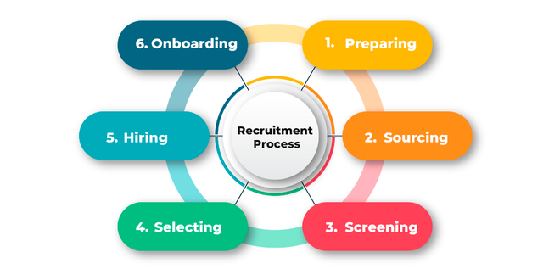

By thoroughly understanding the requirements and challenges faced by HR managers at each stage of the recruitment process, you can create detailed customer journey maps that guide the development and improvement of recruiting assistance solutions. These maps will help ensure that the solutions effectively address the specific needs and pain points of HR managers within your organization.